VISTAARFINANCIALSERVICESPRIVATELIMITED
RCU VERIFICATION REPORT
(SKYLINERISKAUDITSERVICES)
STATE | TN-C
BRANCH | Coimbatore2
LOANACCOUNTNUMBER | 00024700SBML00000295 // DB202607022385574
PRODUCT | Saral
APPLICANTNAME | SELVARAJ T
CO-APPLICANTNAME | MERI
LOANAMOUNT | 500000
SAMPLEDDOCUMENTS | RV AND BV
PICKUPCRITERIA | TRIGGER
SAMPLEDDATE | 24/07/2026
REPORTDATE | 27/07/2026
TAT | 3
DISBURSEMENTTYPE | PRE

AGENCYDEDUPESTATUS REMARKS | NOADVERSEFOUND
VISITEDRESIDENCE ADDRESS | 2 66A PICHANOOR POST ANNA NAGAR PICHANUR COIMBATORE Tamil Nadu 641105
NEIGHBOUR/THIRD PARTY CHECK / | As per the neighbour's confirmation male – name not disclosed, the applicant is residing at the given address. The neighbour confirmed the applicant's name and stated that there is no negative feedback about the applicant.
REFERENCEREMARKS
FORRESIDENCEADDRESS
RESIDENCEADDRESS VERIFICATIONREMARKS | RESIDENCE ADDRESS VERIFICATION: STATUS: POSITIVE  Visited the given residence address. Met the applicant. He confirmed that the given address is his own house and that he has been residing there for the past 25 years. Total family members are two. The house is an RC building of approximately 350 sq.ft. The applicant further confirmed that he has been working as a Spinning Machine Operator at Vantex Company for the past seven years.  Residence location is middle class area.

VISITEDBUSINESS ADDRESS | 2 66A PICHANOOR POST ANNA NAGAR PICHANUR COIMBATORE Tamil Nadu 641105
NEIGHBOUR / THIRD PARTY CHECK / REFERENCEREAMRKS FORBUSINESSADDRESS | As per neighbour confirmation, the applicant has been working at Vantex Company. The address provided for verification is only the applicant's residential address
BUSINESS ADDRESS VERIFICATIONREMARKS | EMPLOYMENT PROFILE VERIFICATION: STATUS: NEGATIVE  Visited the given office address. The given office address is the applicant's residence address. Met the applicant. He confirmed that he has been working as a Spinning Machine Operator at Vantex Company for the past 07 years. No business activity, business operation, business setup and business stock was found at the given address, as it is only a residential premises. The applicant did not provide his actual office address for verification.
DOCUMENTS VERIFICATIONCHECK REMARKS | NA
TRC/ANYOTHERCHECKS REMARKS | NA
RCUVERIFICATION STATUS | NEGATIVE

RESIDENCE CUM BUSINESS PHOTOS

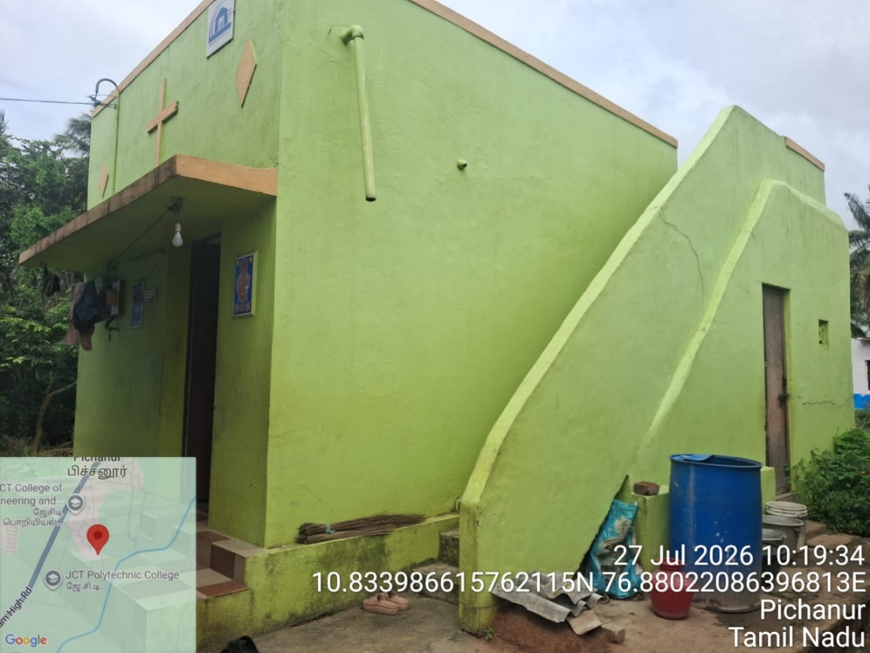

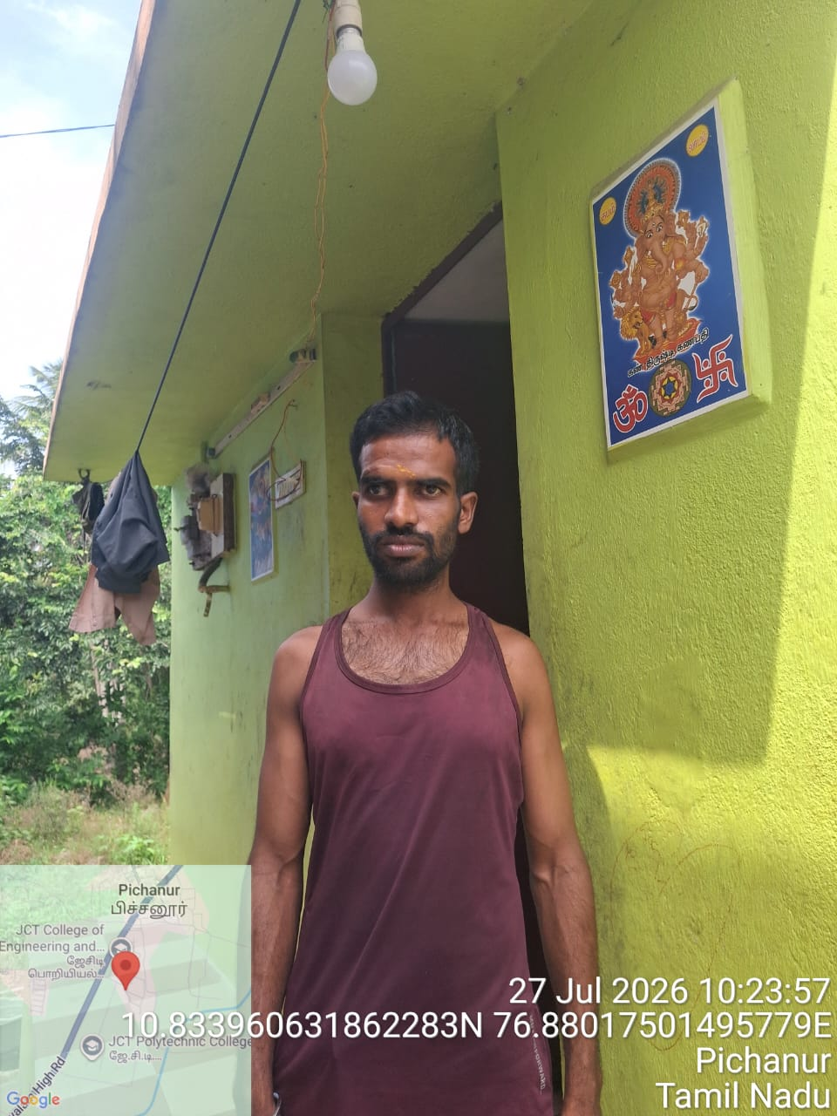

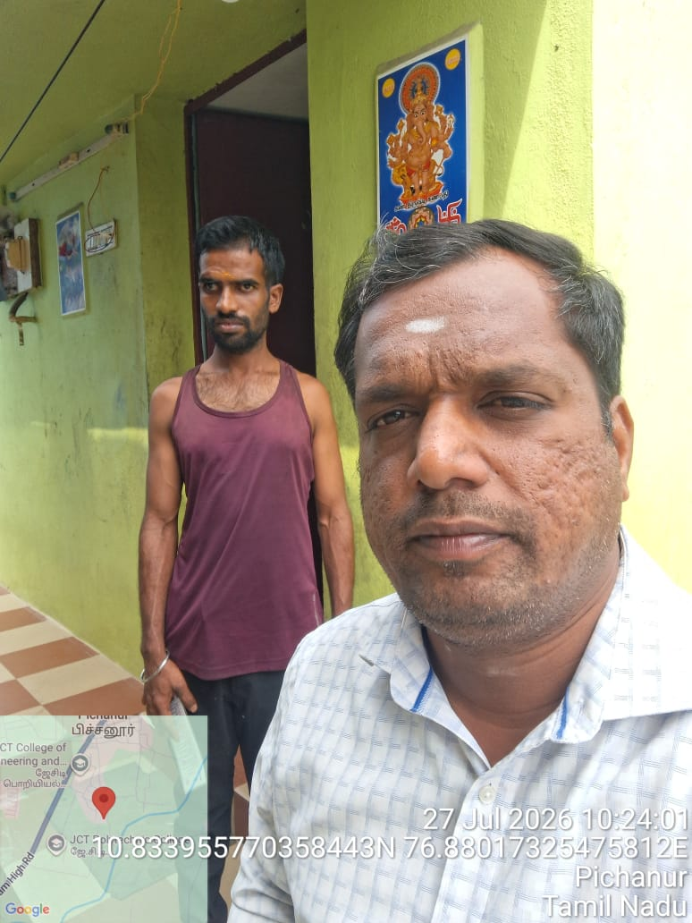

NAME OF VERIFIER: DURAISAMY

SIGNATURE & SEAL THE AGENCY

